WEEK 1
Step 1: Create VLANs on the Switch
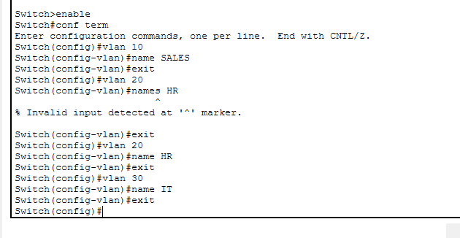

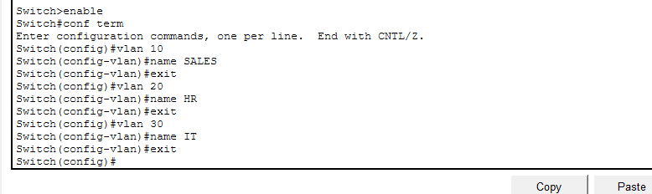

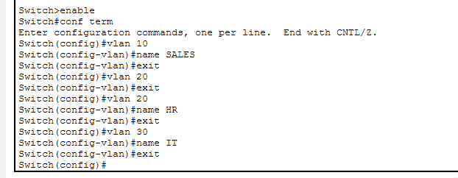
Step 2: Assign Ports to VLANs
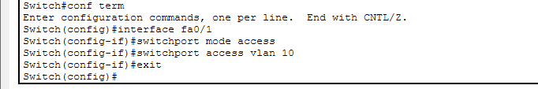

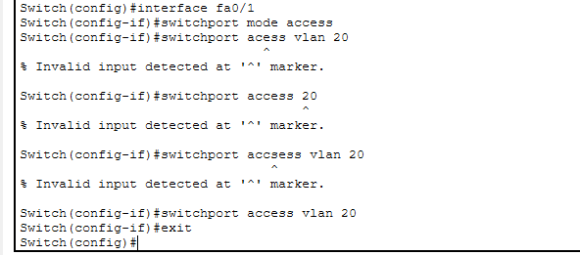

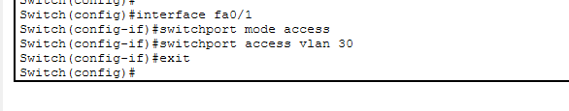
Step 3: Configure Trunk Link to Router
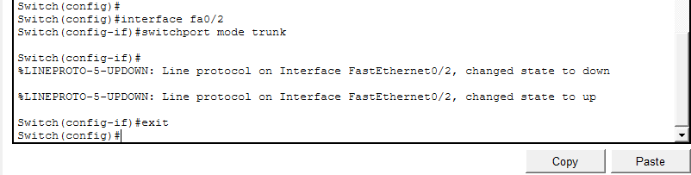

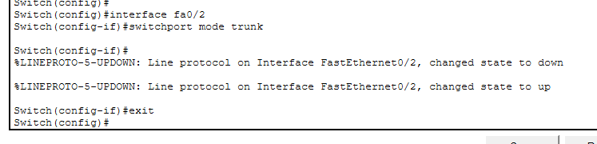

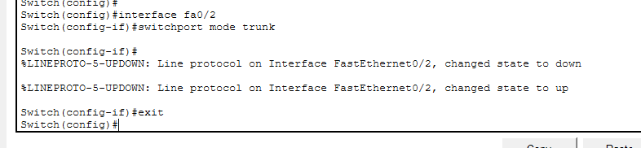

Step 4: Configure Router-on-a-Stick
R1
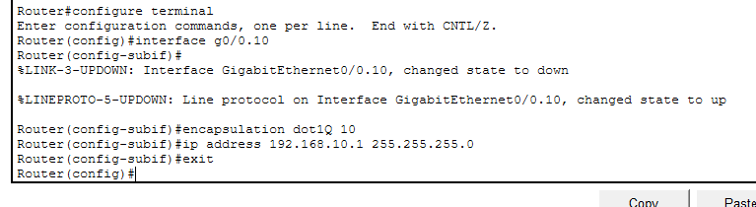
R2
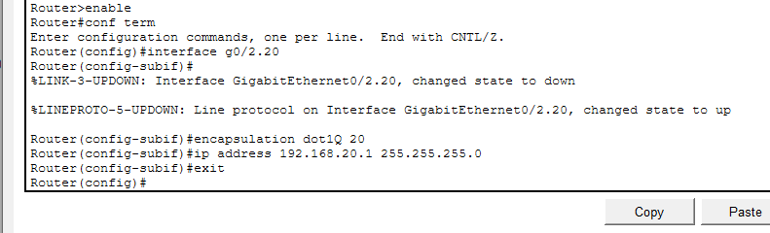
R3
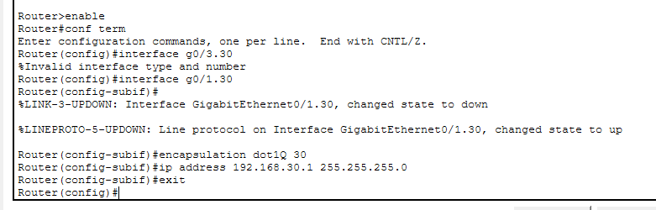

Verification
show vlan brief
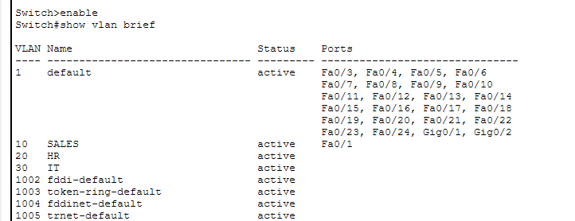
show interfaces trunk
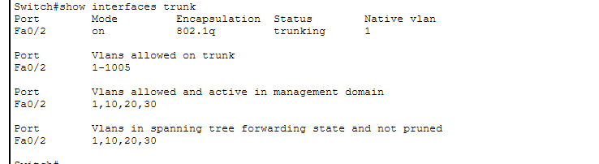
ping 192.168.20.10

